**DYNA STEM: Translating Planning into Strategies**

**UPDATED 2023**

**Update notes:** After further planning conversations, additional perspectives, theories, and research have been integrated into the identification of strategies for supporting neurodiverse undergraduate students pursuing STEM degrees. Within each section are updated notes that show the evolution of thought.

# Theories

* Social innovation of systems transformation
* Adult learning
* Trauma-informed
* Universal design for learning

UPDATE: Other underlying theories and perspectives that broaden our interpretation of how the undergraduate STEM ecosystem is currently and/or should be configured for neurodiverse students are the following.

* Intersectionality: Acknowledging that each person has had unique history of discrimination and oppression leading to variations in how social and systemic factors are experienced.
* Self-determination: Autonomy, competence, and connectedness are critical for growth and learning.
* Symbolic interactionism: Interactions inform meanings and actions are based on meanings.

# What is neurodiversity?

* Natural human variation
* Neurodivergence is diversity
* Neurodivergent thinking includes
  + autism,
  + many forms of learning disabilities such as dyslexia,
  + conditions that affect focus and maintaining engagement often referred to as attention deficit disorders, and
  + sometimes mental health conditions such as anxiety and depression

**Update: How do we talk about neurodiversity?**

* Use identity-led language.
* Frame language to recognize EVERYONE is different. It is not a binary neurotypical versus not typical (neurodiversity) view of diversity.
* Neurodivergent denotes an individual whereas neurodiverse denotes a group of individuals.

# Why increase neurodiversity in STEM?

* STEM careers need a diverse workforce in order to truly perceive the world’s STEM challenges and solutions
* Creative thinking leads to innovation
* Neurodivergent thinkers often notice things that non-divergent thinkers overlook, miss, or do not see at all
* Increase employment opportunities for people with diverse abilities

# What do neurodiverse students tell us about their learning?

* Time: I need more time and the time of day matters
* Environments: Not all settings are conducive to my learning
* Self-guided learning: Need to use my own strategies for teaching myself
* Social aspects: Navigating group assignments can be tricky to nearly impossible without guidance, but that doesn’t mean I don’t want to do group activities.
* Social aspects: I am aware that I think differently, but that doesn’t make me less capable*.*

# What characteristics of undergraduate teaching and learning do neurodiverse students recommend?

1. Specific, clear instructions
2. Flexibility for self-guided learning
3. Balance of peer learning, hands-on, and direct instructions (aka-not just lecture or not just group project)
4. Choice: Options to choose and not choose activities or steps
5. Visuals and graphics, not just text-based
6. Opportunities to be creative
7. Clear, logical applications to real-world STEM work
8. Sensory stimuli focused on specific tasks
9. Physical space options for standing and sitting, with options for orientation in the space
10. Clear social expectations

# Solutions for improving undergraduate teaching and learning—universal design and more

The integration of universal design for learning, adult learning principles, and trauma-informed principles is a strategy for improving the quality of core STEM instruction, across all STEM content areas. Together these elements address most of what neurodiverse students identified as consistent with a supportive learning environment. Furthermore, when the integration of these three elements was shared with colleagues, all agreed that these are consistent with quality teaching.

**Update:** Intersectionality has been added to the model.

**Figure 1.** Three elements of quality core STEM teaching and learning

The following side-by-side tables show the alignment between the three elements and reflection questions for STEM faculty about their teaching and the learning environment.

## Universal design for learning

|  |  |
| --- | --- |
| Multiple methods of:   * Representation: Information shared in varied ways * Action & Expression: Options for demonstrating learning * Engagement: Options for interacting with new information and learning new skills | Faculty reflection questions:  *Do I provide…*   * *Varied ways for students to access course content?* * *Varied ways of working with the content?* * *Varied ways of showing what they have learned?* * *Varied ways of practicing new skills?* |

## Trauma-informed learning environment

|  |  |
| --- | --- |
| Principles:   * Safety: Risk-taking is an acceptable form of STEM learning * Trustworthiness: Dependable follow-through * Choice: Options for engagement * Collaboration: Learning from each other, working toward a common goal * Empowerment: Strengths-based approach, providing an opportunity for leadership | Faculty reflection questions:  *Do I provide…*   * *Opportunities to try out ideas and test hypotheses without risk of a low grade or peer scrutiny?* * *Do I adhere to my course plans? Are necessary changes explained to students?* * *Offer opportunities for students to make choices about their learning?* * *Promote peer-to-peer learning and mutually reinforcing activities?* * *Advise students from a strengths-first perspective?* * *Provide opportunities for all students to showcase various forms of leaders?* |

## Adult learning principles

|  |  |
| --- | --- |
| Principles:   * Preparation: Plan, introduce, & illustrate * Relevance: Application and practice * Reflection: Self-assessment & goal setting | Faculty reflection questions:  *Do I provide…*   * *Clear introductions and illustrations of what is to be learned?* * *Descriptions of why and how the content is relevant and how it is used in real-world/ professional settings?* * *Opportunities for students to self-assess their mastery of the content?* * *Guidance for students regarding next steps in their learning based on their self-assessment?* |

**Update:** Intersectionality has been added to the model.

**Figure 2.** Updated four elements of quality core STEM teaching and learning

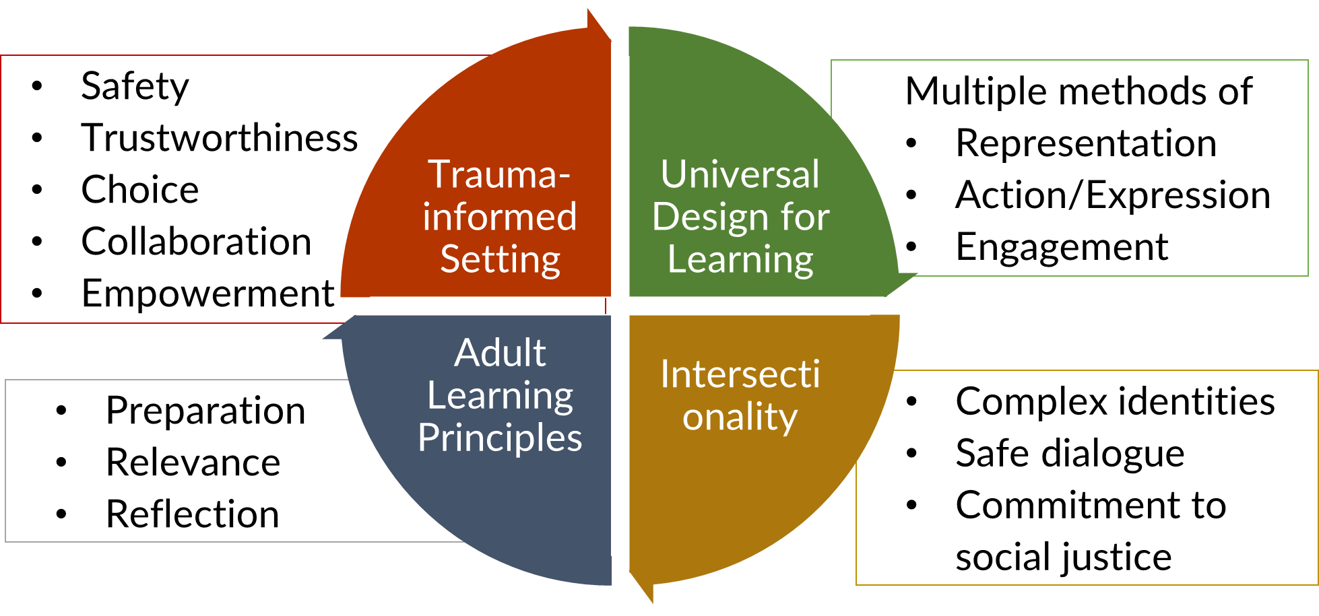

## Intersectionality

|  |  |
| --- | --- |
| Principles:   * Recognition of multiple, complex student identities * Commitment to open discussions regarding experiences of discrimination, oppression, or marginalization * Commitment to social justice | Faculty reflection questions:  *Do I provide…*   * *Opportunities and a safe setting for students to share diverse perspectives?* * *Opportunities for students to share their personal experiences of discrimination, oppression, or marginalization.* * *Opportunities for discussion, questioning, and input about ways of improving social and power dynamics that are either implicit or explicit in the learning environment.* |